HELP DESK METRICS
DASHBOARD REPORT
Monthly Help Desk Performance Summary
Field | Details
Prepared by | Britany Walker
Document Type | Help Desk Metrics and Performance Dashboard
Reporting Period | Monthly Help Desk Performance Summary
Version | 1.3
Date | May 2026
Classification | Original Portfolio Document - No Client or Employer Data
Intended Use | Portfolio documentation demonstrating help desk reporting, SLA tracking, ticket analysis, and operational improvement planning

Portfolio Notice: This report is an original portfolio-based IT support documentation sample. It uses sample help desk metrics and does not include confidential company data, client information, real user records, or proprietary system details.

Table of Contents
1) Executive Summary
2) Dashboard Snapshot
3) KPI Interpretation
4) Ticket Volume by Category
5) SLA Performance: Targets vs. Actuals
6) Incident Trends and Observations
7) Operational Recommendations and Action Plan
8) Ticket Documentation Standards
9) Quality Review Checklist
10) Approval and Sign-Off
11) Revision History
12) Closing Notes

1. Executive Summary
This monthly help desk dashboard gives a clear overview of support activity during the reporting period. It reviews ticket volume, resolution progress, first response time, SLA performance, common ticket categories, and areas where the support process can improve.
During the month, the help desk handled 428 tickets and resolved 401 of them. This left 27 tickets open for continued follow-up, giving the team a strong resolution rate of 93.7%. SLA compliance was also strong at 96%, with an average first response time of 1.8 hours and an average resolution time of 5.4 hours.
Overall, the numbers show a stable support process with timely responses and a manageable open-ticket count. The biggest opportunity for improvement is reducing repeat tickets. Password resets, email support, and network or Wi-Fi issues made up the largest share of the workload. To help lower these repeat requests, the next steps should include improving self-service password reset instructions, creating simple user guides for VPN, MFA, and Outlook sync issues, and tracking network problems by device, location, and time of day.

2. Dashboard Snapshot
The help desk processed a total of 428 tickets during the month. Of those, 401 were resolved and 27 remained open. This shows that the team was able to close most requests while keeping the backlog under control.
The average first response time was 1.8 hours, which means users were acknowledged quickly. This likely helped reduce follow-up requests and gave users confidence that their issues were being reviewed. The average resolution time was 5.4 hours, which is reasonable for a mixed support queue that includes password resets, software issues, email problems, network concerns, and printer requests.
SLA compliance reached 96%, showing that the team met service expectations for most tickets.
Metric | Value | Status / Interpretation
Total Tickets Processed | 428 | Total monthly help desk workload
Resolved Tickets | 401 | Closed and confirmed as resolved
Open Tickets | 27 | Remaining tickets needing action or follow-up
Ticket Resolution Rate | 93.7% | Strong closure rate; backlog stayed controlled
Average First Response Time | 1.8 hours | Timely first contact helped reduce follow-up noise
Average Resolution Time | 5.4 hours | Reasonable for a mixed support queue
SLA Compliance Rate | 96% | Strong adherence to service targets
Resolution Rate | 401 / 428 | 93.7%
Open Ticket Share | 27 / 428 | 6.3%
SLA Miss Rate | 100% - 96% | 4%

3. KPI Interpretation
The resolution rate of 93.7% shows that the support team closed the majority of tickets during the reporting period. The remaining open tickets should continue to be reviewed so that blockers, escalations, or user follow-ups do not create delays.
The first response time was also a positive result. Responding to users in under two hours on average helped keep communication moving and allowed urgent issues to be identified sooner.
The average resolution time of 5.4 hours suggests that most issues were handled within a reasonable timeframe. Any tickets that took longer should be reviewed to see whether delays were caused by approvals, user availability, hardware needs, or escalation requirements.
The 96% SLA compliance rate is a strong result. It shows that priority handling, communication, and ticket ownership were effective overall.
KPI | What the Number Indicates | Operational Meaning
Resolution Rate | Most tickets were closed during the period. | The backlog remained manageable and support ownership appears consistent.
First Response Time | Users received a first response in under two hours on average. | Early acknowledgement helped reassure users and triage urgent issues faster.
Resolution Time | Average closure time was 5.4 hours. | Longer tickets should be reviewed for approval delays, user availability, hardware dependency, or escalation needs.
SLA Compliance | 96% of tickets met target service levels. | Priority handling and communication practices were effective overall.

4. Ticket Volume by Category
Password reset requests were the largest category, with 102 tickets, or 24% of the total volume. This suggests that users may need clearer password reset instructions, account recovery steps, or support with MFA-related sign-in problems.
Email support was the second-largest category, with 95 tickets, or 22%. Many of these issues may be connected to Outlook sync problems, mailbox access, credential prompts, or send and receive errors. A short Outlook troubleshooting guide could help reduce these requests.
Network and Wi-Fi issues accounted for 88 tickets, or 21% of the total. Because these problems can be tied to location, device type, VPN access, signal strength, or DNS issues, they should be tracked more closely for patterns.
Software troubleshooting made up 82 tickets, or 19%. These tickets included application errors, updates, permissions, and configuration problems.
Printer issues were the smallest category, with 61 tickets, or 14%. This may show that driver standardization and routine troubleshooting are helping keep printer-related requests under control.
Together, password resets, email support, and network or Wi-Fi issues made up 67% of all tickets. These areas should be the main focus for knowledge base updates, user education, and repeat-issue tracking.
Figure 1. Sample ticket volume distribution by category for the monthly reporting period.
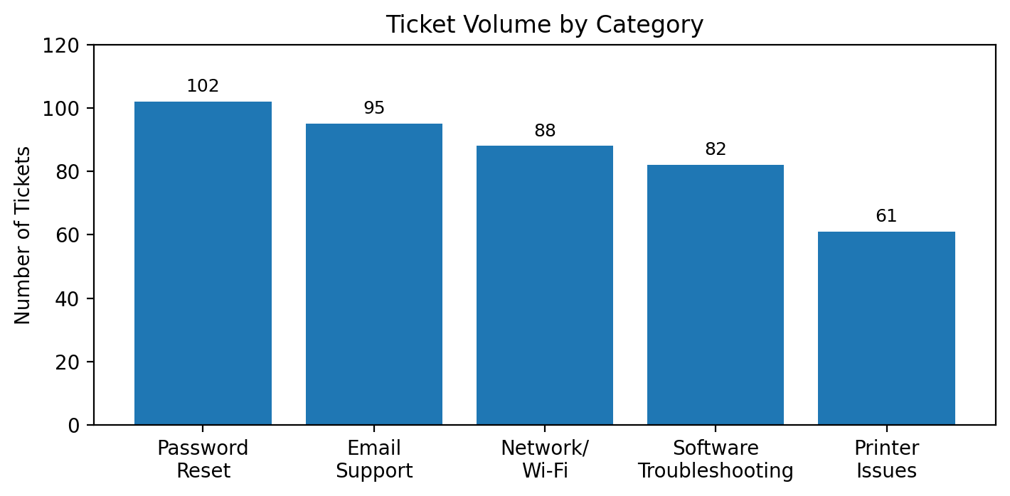
Category | Tickets | Percentage | Insight
Password Reset | 102 | 24% | Largest driver; strong candidate for self-service reset guidance and clearer account recovery instructions
Email Support | 95 | 22% | Common pain point; Outlook sync and mailbox troubleshooting should be standardized
Network/Wi-Fi | 88 | 21% | Frequent connectivity issue; patterns should be tracked by device, location, and time
Software Troubleshooting | 82 | 19% | Includes application errors, updates, permissions, and configuration problems
Printer Issues | 61 | 14% | Lowest category; driver standardization and routine troubleshooting may be helping

5. SLA Performance: Targets vs. Actuals
SLA targets were met across all priority levels.
Critical tickets had a target resolution time of 2 hours, and the actual average was 1.5 hours. This shows that urgent issues were identified and routed quickly.
High-priority tickets had a target of 4 hours, and the actual average was 3.2 hours. This suggests that work-blocking issues were handled within the expected timeframe.
Medium-priority tickets had a target of 1 business day, and the actual average was 6.8 hours. This shows that routine productivity issues stayed under control.
Low-priority tickets had a target of 2 business days, and the actual average was 1.1 business days. This means lower-impact requests did not create a major backlog.
Priority | Target Resolution | Actual Average | Status | Operational Note
Critical | 2 hours | 1.5 hours | Met target | Handled within the expected outage response window
High | 4 hours | 3.2 hours | Met target | Urgent work-blocking issues were resolved inside target
Medium | 1 business day | 6.8 hours | Met target | Routine productivity issues remained controlled
Low | 2 business days | 1.1 business days | Met target | Lower-impact requests did not create a backlog

6. Incident Trends and Observations
Password-related tickets remained high throughout the month. These requests may have been caused by forgotten passwords, expired credentials, account lockouts, or MFA challenges. The best next step is to improve self-service instructions and review the most common reasons users are getting locked out.
Email issues also remained a common support need. Outlook synchronization problems, mailbox limits, credential prompts, and send or receive errors may all be contributing to the ticket volume. A short, user-friendly Outlook troubleshooting guide would help users try basic fixes before submitting a ticket.
Network and Wi-Fi problems continued to appear as recurring issues. These may be connected to access points, weak signal areas, VPN drops, DNS problems, or device-specific failures. Tracking these tickets by device, location, and time of day would make it easier to find patterns.
Printer tickets were the lowest-volume category. This may show that standard drivers, routine troubleshooting, and proactive maintenance are helping reduce repeat printer issues.
Trend | Observation | Recommended Follow-Up
Password requests stayed high | Forgotten passwords, expired credentials, lockouts, and MFA friction may be driving repeat requests. | Improve self-service instructions and review common lockout causes.
Email issues remained frequent | Outlook synchronization, credential prompts, mailbox limits, and send/receive errors likely contributed to volume. | Create a short Outlook troubleshooting quick reference.
Network/Wi-Fi issues were recurring | Connectivity problems may relate to access points, weak signal, VPN drops, DNS issues, or device-specific failures. | Track by device, location, and time to find patterns.
Printer tickets were lowest | Standard drivers and routine troubleshooting appear to be controlling repeat incidents. | Continue driver standardization and proactive maintenance.

7. Operational Recommendations and Action Plan
The first recommendation is to expand self-service password reset guidance. Clearer instructions can help users recover access faster and reduce the number of password reset tickets submitted to the help desk.
The second recommendation is to create short user guides for VPN, MFA, and Outlook sync issues. These guides should be simple, direct, and easy for users to follow. This can reduce repeat tickets and improve first-contact resolution.
The third recommendation is to track repeat network issues by device, location, and time. This will help the team identify whether problems are tied to access points, DNS, VPN, gateways, or specific devices.
The fourth recommendation is to continue printer driver standardization and proactive updates. Since printer tickets were the lowest category, the current process appears to be working and should be maintained.
The final recommendation is to review open tickets weekly and document any blockers. This will help prevent backlog growth and improve ticket ownership.
Recommendation | Expected Benefit | Owner | Priority | Target Review
Expand self-service password reset guidance | Reduces password reset tickets and speeds up access recovery | IT Support / Identity | High | 30 days
Create short user guides for VPN, MFA, and Outlook sync | Reduces repeat tickets and improves first-contact resolution | Help Desk Lead | High | 30 days
Track repeat network issues by device, location, and time | Helps identify access point, DNS, VPN, or gateway patterns | Network Support | Medium | 60 days
Continue printer driver standardization and proactive updates | Maintains lower printer incident rate | Desktop Support | Medium | Quarterly
Review open tickets weekly and document blockers | Prevents backlog growth and improves ownership | Support Manager | Medium | Weekly

8. Ticket Documentation Standards
Clean reporting depends on clear ticket notes. Each ticket should include enough detail for another technician to understand the issue, the steps taken, the outcome, and any follow-up needed.
Each ticket should identify the affected user, device, application, or service. It should also include the correct issue category and priority level.
Troubleshooting steps should be listed in the order they were completed, along with the result of each step. If the ticket is escalated, the notes should explain which team received it, why it was escalated, and what blocker remains.
The final resolution should clearly explain what fixed the issue and whether the user confirmed that the problem was resolved.
Required Detail | Documentation Standard | Example
User and affected system | Record the user, device, application, or service affected. | User reported Outlook sync failure on assigned laptop.
Issue category and priority | Use consistent categories and priority levels. | Email Support - Medium priority.
Troubleshooting steps | List actions taken and results in order. | Restarted Outlook, tested webmail, checked offline mode.
Escalation notes | Identify receiving team, reason, and current blocker. | Escalated to Tier 2 due to repeated credential prompt.
Final resolution | Summarize what fixed the issue and whether user confirmed. | Profile repair completed; user confirmed mail sync restored.

9. Quality Review Checklist
Review Item | Pass / Needs Review | Reviewer Notes
Dashboard metrics align with source ticket totals | ☐ Pass ☐ Needs Review
Ticket categories are consistent across the report | ☐ Pass ☐ Needs Review
SLA values include targets, actuals, and status | ☐ Pass ☐ Needs Review
Recommendations are tied to observed trends | ☐ Pass ☐ Needs Review
No client, employer, user, or confidential data appears | ☐ Pass ☐ Needs Review

10. Approval and Sign-Off
Role | Name | Signature | Date | Comments
Document Owner | Britany Walker |  |  | Original author
IT Reviewer
Support Manager

11. Revision History
Version | Date | Description of Change | Author
1.0 | May 2026 | Initial help desk metrics dashboard report created for portfolio documentation sample. | Britany Walker
1.1 | May 2026 | Corrected numbering, strengthened dashboard structure, added chart, quality checklist, approval section, and revision history. | Britany Walker
1.2 | May 2026 | Cleaned formatting, rebuilt charts, improved table spacing, and standardized report layout. | Britany Walker
1.3 | May 2026 | Added humanized narrative content while preserving the key help desk metrics, tables, chart, and portfolio structure. | Britany Walker

12. Closing Notes
This month’s sample help desk performance shows a steady support operation with strong SLA compliance, quick first response times, and a controlled open-ticket count.
The next improvement cycle should focus on reducing repeat password, email, and network tickets. Clearer self-service guidance, simple user education materials, and better recurring-issue tracking can help lower ticket volume and improve the overall support experience.
End of Report

